SUPPLEMENTARY MATERIAL
Assessment of fatal cardiovascular disease risk using data-driven diabetes subgroups and SCORE2-Diabetes in 24,943 adults in Mexico City
Jerónimo Perezalonso-Espinosa^{1.2}, Juan Pablo Díaz-Sánchez^{1,2}, Daniel Ramírez-García^{1,3}, Karime Berenice Carrillo-Herrera^{1,3}, Leslie Alitzel Cabrera-Quintana^{1,3}, Carlos A. Fermín-Martínez^{1,2}, Martín Roberto Basile-Álvarez^{1,3}, Andrea Malagón-Liceaga^{1,3}, Jaime Berumen⁴, Pablo Kuri-Morales^{4,5}, Roberto Tapia-Conyer⁴, Jesus Alegre-Díaz^{4,+}, Neftali Eduardo Antonio-Villa^{6,7,+}, Goodarz Danaei⁶, Jacqueline A. Seiglie^{8,9+}, Omar Yaxmehen Bello-Chavolla^{1,6*}

SUPPLEMENTARY METHODS

Adaptation of the SNNN algorithm to MCPS data
Cluster classification in NHANES-III and NHANES-IV
Based on methods previously developed by our group¹, we adapted our self-normalizing artificial neural network (SNNN) algorithm to fit MCPS data using NHANESS-III as a training dataset and NHANES-IV as a validation dataset. Amongst 13,866 participants in NHANES-III, 1,665 had diabetes defined as self-reported diabetes, HbA1c ≥6.5%, or fasting plasma glucose ≥126mg/dL; similarly, amongst 41,810 participants in NHANES-IV 6,392 had diabetes as per the same definition. Next, we included only participants with recently-diagnosed diabetes defined as ≤5 years from diabetes onset, and filtered those with HOMA2-IR, HOMA2-B, age from diabetes onset, BMI and HbA1c ≥5 standard deviations from the population mean to derive diabetes clusters as proposed by Ahlqvist et al.², yielding 1,017 participants in NHANES-III and 449 participants in NHANES-IV with complete data to estimate diabetes clusters. In both NHANES-III and NHANES-IV, diabetes subgroups were classified using k-means clustering after data centering and scaling to mean 0 and standard deviation of 1, to derive a four cluster solution with 1,000 runs using the fpc R package and assessed cluster stability using clusterwise Jaccard jittering means yielding coefficients >0.97 using 1,000 boostrap samples with the clusterboot R package.
Fitting of the modified SNNN algorithm
We used the derived cluster classification in NHANES-III (n=1,017) as the gold standard and developed a SNNN algorithm using the keras R package, which classified diabetes subgroups based on variables available in the MCPS dataset including BMI, systolic and diastolic blood pressure, HbA1c, age at diabetes diagnosis and the waist-to-height ratio (WHtR). The SNNN model had three hidden layers, including a 32-unit dense layer with a LeCun normal intializer, an alpha droput layer with an alpha rate of 0.2 and a 4-unit dense layer with a Softmax activation function as the output layer. The model was fitted using an ADAM optimizer, a SeLU activation function, and a sparse categorical cross-entropy loss function, and was trained for 20 epochs using the keras and reticulate R package, as shown below:
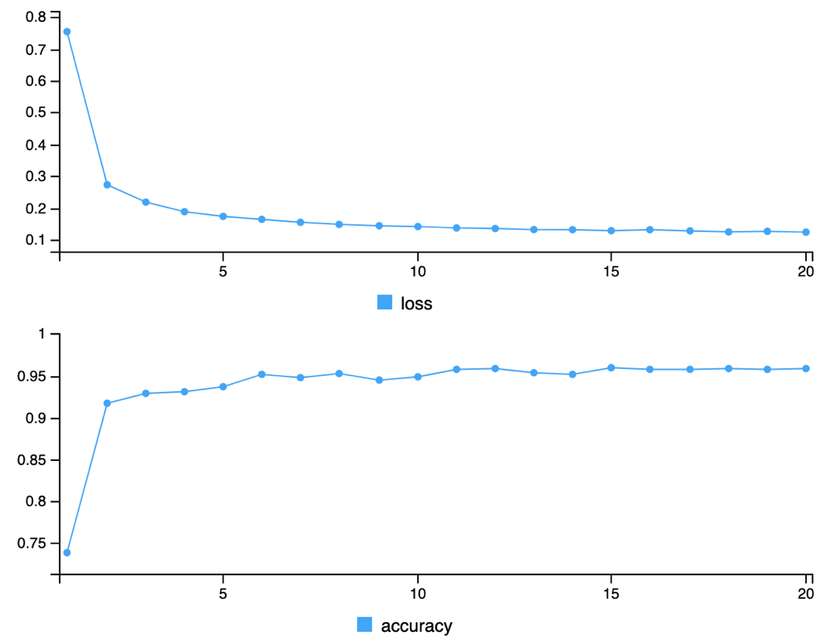
Figure A. Changes in loss function and accuracy over 20 epochs of training for the SNNN model to classify diabetes subgroups using NHANES-III data.
Performance of the SNNN algorithm in NHANES-III and IV
First, we compared the performance of using k-means clustering with variables available in MCPS to derive diabetes subgroups compared to the original cluster classification using the methods proposed by Ahlqvist et al. in the NHANES-IV validation sample (n=449), along with the performance of the classified subgroups using the SNNN model both in the training and validation samples. We observed decreased accuracy and concordance when using k-means clustering compared to the original variables, with marked worsening in the validation sample (Table A). In contrast, the SNNN model yielded improved accuracy and concordance, with similar performance in both the training and validation sample indicating the validity of the SNNN approach for reproducing diabetes subgroups proposed by Ahlqvist et al. using variables available in MCPS.
Method | Accuracy (95%CI) | Kappa (95%CI)
Simple k-means clustering training sample | 0.785 (0.758-0.810) | 0.705 (0.669-0.741)
Simple k-means clustering validation sample | 0.737 (0.694-0.778) | 0.630 (0.577-0.683)
SNNN model validation sample | 0.924 (0.895-0.947) | 0.886 (0.829-0.944)
SNNN model training sample | 0.928 (0.901-0.943) | 0.899 (0.863-0.936)
Table A. Performance and concordance of the k-means clustering compared to the SNNN approach for classifying diabetes subgroups as proposed by Ahlqvist et al. using training data in NHANES-III and validated in NHANES-IV for individuals with recently-diagnosed diabetes.

Performance of the SNNN algorithm for specific diabetes subgroups
Next, we assessed whether the SNNN model was adequate for identifying specific diabetes subgroups in the NHANES-IV validation sample. To this end, we compared sensitivity, specificity, positive and negative predictive values and balanced accuracy using the caret R package.We observed consistent performance across diabetes subgroups, with a slightly reduced accuracy for the MARD subgroup (Table B).
Cluster | Sensitivity | Specificity | PPV | NPV | Balanced accuracy
SIDD | 99.72% | 90.32% | 97.5% | 98.8% | 95.02%
SIRD | 95.9% | 100.0% | 100.0% | 84.4% | 98.0%
MOD | 96.3% | 97.7% | 99.7% | 74.1% | 97.0%
MARD | 98.6% | 89.4% | 90.0% | 98.6% | 94.1%
Table B. Diagnostic performance of the SNNN approach for classifying diabetes subgroups in NHANES-IV for individuals with recently-diagnosed diabetes. Abbreviations: MOD, Mild Obesity-related Diabetes; MARD, Mild Age-related Diabetes; SIDD, Severe Insulin-Deficient Diabetes; SIRD, Severe Insulin-Resistant Diabetes.

When assessing the clinical features of diabetes subgroups as reproduced by the SNNN algorithm we observed that the SIDD subgroup had the lowest HOMA2-B values, and the highest HbA1c levels compared to the rest of the subgroups. The SIRD subgroup had slightly increased HOMA2-B with elevated HOMA2-IR, BMI and WHtR values which are indicative of increased visceral adiposity. In contrast, the MARD subgroup was characterized by a milder phenotype with increased age at diabetes diagnosis, whilst the MOD phenotype had the lowest age at diabetes diagnosis and the lowest HbA1c values, as seen in Figure B.
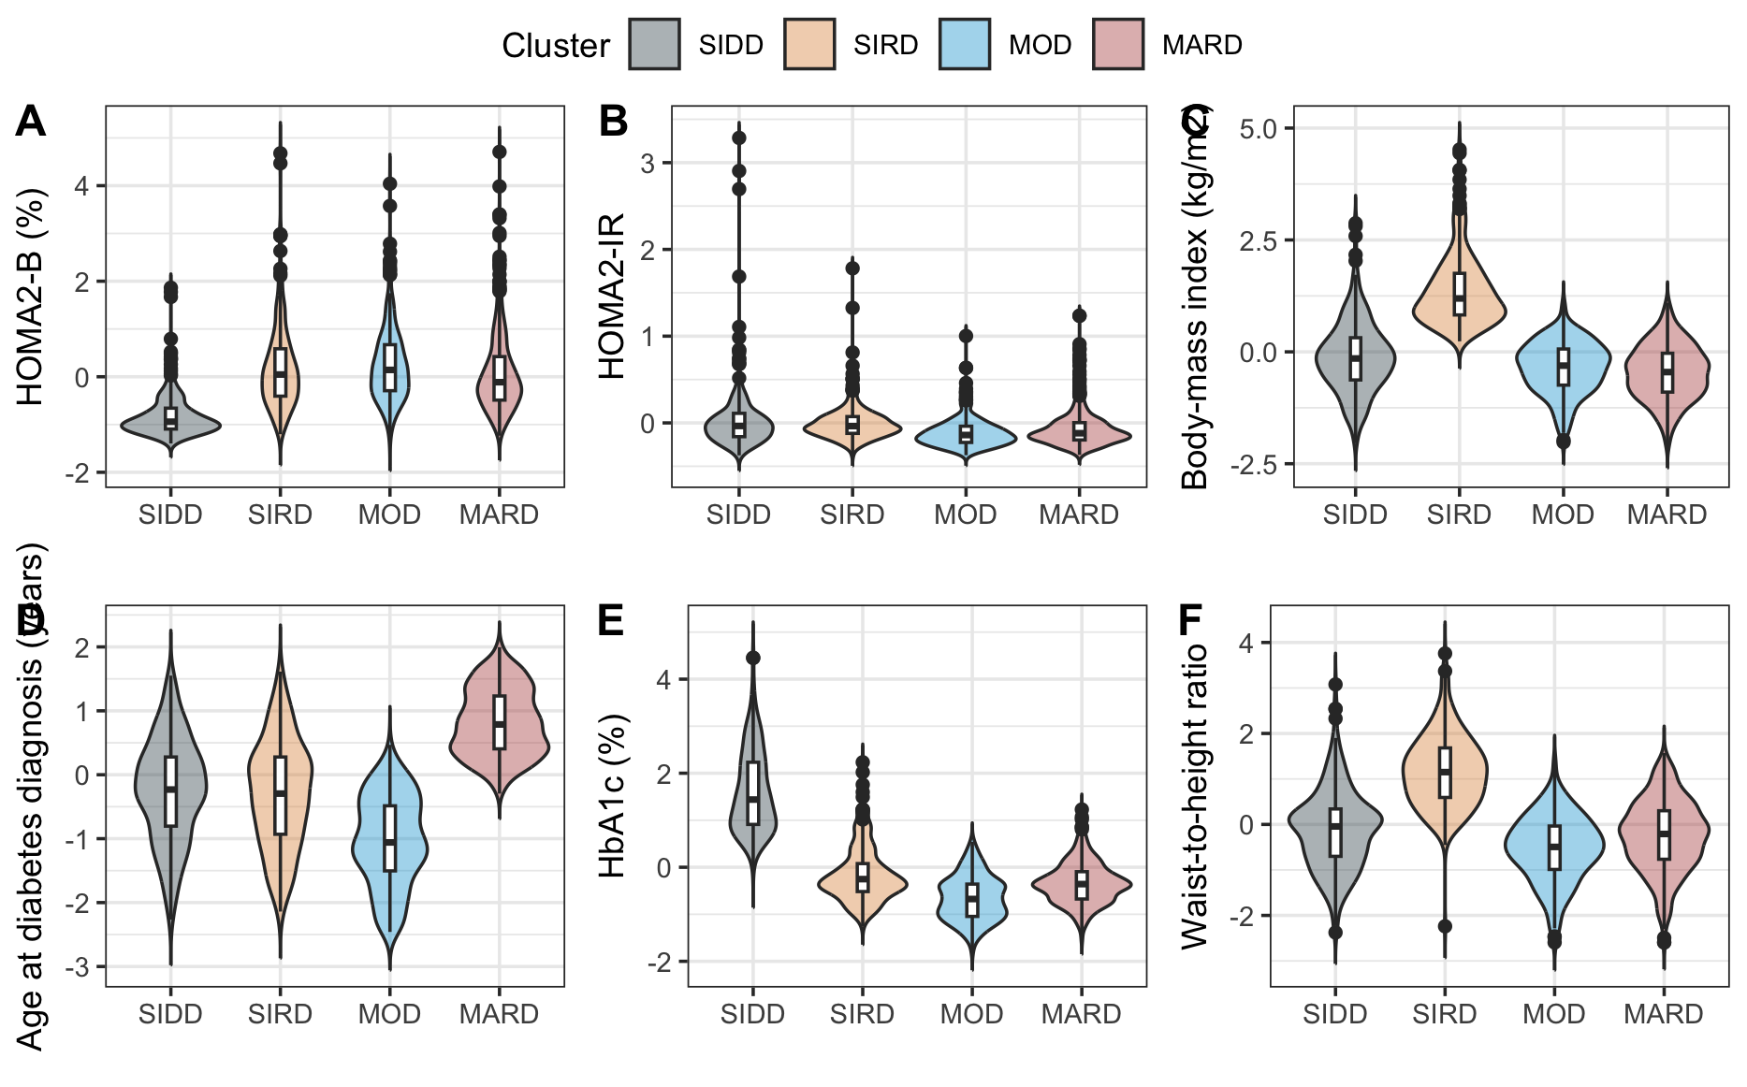
Figure B. Clinical characteristics of data-driven diabetes subgroups classified using SNNN algorithms in NHANES-III and NHANES-IV data. Abbreviations: MOD, Mild Obesity-related Diabetes; MARD, Mild Age-related Diabetes; SIDD, Severe Insulin-Deficient Diabetes; SIRD, Severe Insulin-Resistant Diabetes.

Recalibration of SCORE2-Diabetes for fatal CVD outcomes
To account for differences in baseline hazard and risk distribution between the for fatal outcomes compared to the original composite outcome of fatal and non-fatal outcomes, the SCORE2-Diabetes model was recalibrated for fatal cardiovascular disease (CVD) outcomes using a Cox proportional hazards framework. To this end, we let $h\left(t | η_{i}\right)=h_{0}{(t)e}^{η_{i}}$ denote the hazard function for subject $i$, where $h_{0}(t)$ is the baseline hazard and $η_{i}$ represents the original linear predictor for SCORE2-Diabetes estimated as the prognostic index. First, we estimated the recalibration slope for SCORE2-Diabetes by fitting a univariate Cox proportional hazard regression model using the linear predictor as the sole covariate, denoted by:
$$h\left(t | η_{i}\right)=h_{0}\left(t\right)*\exp\left(β_{recal}η_{i}\right),$$
where $β_{recal}$ denotes the calibration slope. This parameter quantifies the degree of over- or underestimation of risk by the original model and was estimated using partial maximum likelihood with the Efron approximation.
Next, we estimated the recalibrated baseline survival function with an individual with $η_{i}=0$ from the fitted Cox model as:
$${\hat{S}}_{0}\left(t\right)=\operatorname{Pr}\left(T>t \right|η_{i}=0),$$
and evaluated the target prediction horizon $t_{0}=$10 years, yielding ${\hat{S}}_{0}\left(t_{0}\right)$.
This transformation preserved the relative ranking of predicted risks while aligning the overall risk scale with the observed event rates in MCPS population. The recalibrated metrics for SCORE2-Diabetes are presented in Table C below:
Metric | Estimate (95%CI
Recalibration slope ($β_{recal}$) | 0.4504 (0.4188-0.4821)
Baseline survival function ${\hat{S}}_{0}\left(t_{0}\right)$ | 0.979 (0.977-0.982)
Table C. Recalibration metrics of SCORE2-Diabetes for fatal CVD in MCPS
Therefore, for each individual the recalibrated 10-year predicted probability of fatal CVD can be computed as:

$$Recalibrated SCORE2-Diabetes (fatal)=1-{0.979}^{\exp\left(0.4504{*η}_{i}\right)}.$$

Finally, we recalculated SCORE2-Diabetes for fatal CVD outcomes recalibrated for Mexican population using MCPS and compared its moderate calibration to the original model (Figure C). We observed better agreement between observed and predicted risks in the recalibrated model, indicating better risk estimates using this recalibrated version of SCORE2-Diabetes (fatal).
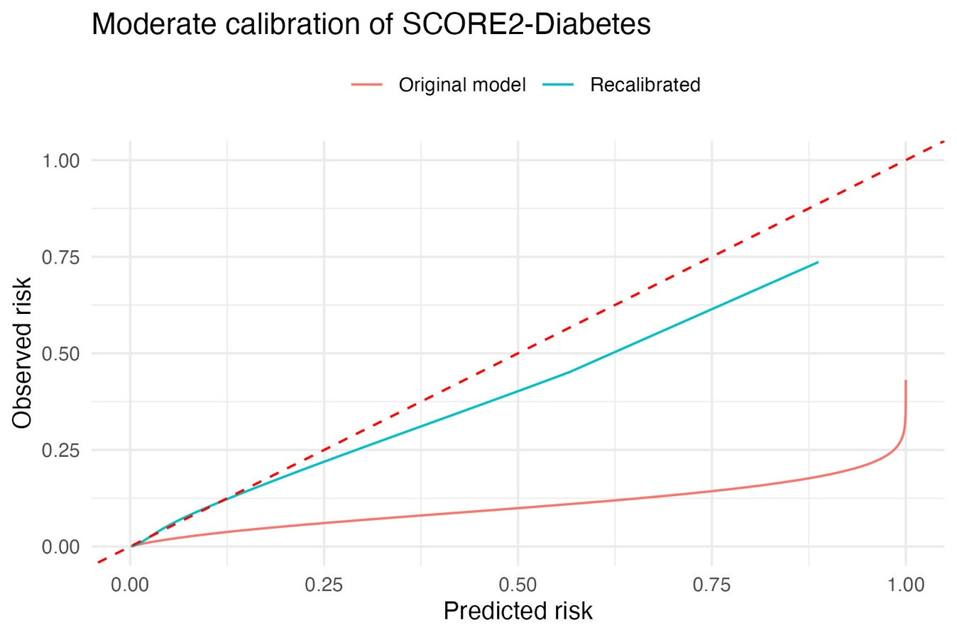
Figure C. Calibration curves of the original SCORE2-Diabetes model and its recalibration for risk of fatal CVD outcomes in MCPS.

A worked example of the use of the recalibrated SCORE2-Diabetes for fatal CVD outcomes is presented below:
1. Linear predictor calculation
Risk factor | Transformed risk factor | Log SHR
 |  | Male | Female
SCORE2 variables
Age (years) | cage = (age - 60)/5 | 0.5368 | 0.6624
Smoking (current vs. non-smoker) | smallbin | 0.4774 | 0.6139
Systolic blood pressure (mmHg) | csbp = (sbp - 120)/20 | 0.1322 | 0.1421
Diabetes (yes vs. no) | hxdiabbin | 0.6457 | 0.8096
Total cholesterol (mmol/l) | ctchol = (tchol - 6)/1 | 0.1102 | 0.1127
HDL cholesterol (mmol/l) | chdl = (hdl - 1.3)/0.5 | -0.1087 | -0.1568
Smoking interaction with age | cage*smallbin | -0.0672 | -0.1122
Systolic blood pressure interaction with age | cage*csbp | -0.0268 | -0.0167
Diabetes interaction with age | cage*hxdiabbin | -0.0983 | -0.1272
Total cholesterol interaction with age | cage*ctchol | -0.0181 | -0.0200
HDL cholesterol interaction with age | cage*chdl | 0.0095 | 0.0186
SCORE2-Diabetes additional variables
Diabetes age at diagnosis (years) | cagediab=(agediab - 50)/5 | -0.0998 | -0.118
HbA1c (mmol/mol) | chba1c=(hba1c - 31)/9.34 | 0.0955 | 0.1173
Ln eGFR (ml/min/1.73m^2) | clnegfr=(lnegfr - 4.5)/0.15 | -0.0591 | -0.0640
Ln eGFR² | clnegfr* clnegfr | 0.0058 | 0.0062
HbA1c interaction with age | chba1c*cage | -0.0134 | -0.0196
Ln eGFR interaction with age | clnegfr*cage | 0.0115 | 0.0169
$$Linear predictor= \sum{(β_{i}{∙η}_{i})}$$
2. Uncalibrated 10-year risk
$$Uncalibrated SCORE2-Diabetes=1- {S(10)}^{exp(linear predictor)}$$
Male |  | Female
$$Uncalibrated SCORE2-Diabetes=1- {0.9605}^{exp(linear predictor)}$$ |  | $$Uncalibrated SCORE2-Diabetes=1- {0.9776}^{exp(linear predictor)}$$
3. Recalibration of 10-year risk
$$Recalibrated SCORE2-Diabetes=1- {{\hat{S}}_{0}(t_{0})}^{exp⁡(β_{recal}⋅lp)}$$
4. Example
Variables | 50 years-old, male, smoker, systolic blood pressure 140 mm/Hg, previous diabetes diagnosis, 6.4 mmol/l total cholesterol, 0.8 mmol/l HDL cholesterol, diagnosis at age 42, 53 mmol/mol HbA1c, 110 ml/min/1.73m^2 eGFR
Transformed risk factors | cage = (50-60)/5 = -2  csbp = (140-120)/20 = 1  ctchol = (6.4-6)/1 = 0.4  chdl = (0.8-1.3)/0.5 = -1  cagediab = (42-50)/5 = -1.6  chba1c = (53-31)/9.34 = 2.35  clnegfr = (ln(110)-4.5)/0.15 = 1.34
Linear predictor | $Lp=\sum{(β_{i}{∙η}_{i})}=\left(0.5368∙-2\right)+\left(0.4774∙1\right) +\left(0.1322∙1\right)+ \left(0.6457∙1\right)+ \left(0.1102∙0.4\right)+ \left(-0.1087∙-1\right)+ \left(-0.0672∙-2∙1\right)+\left(-0.0268∙-2∙1\right)+ \left(-0.0983∙-2∙1\right)+ \left(-0.0181∙-2∙0.4\right)+ \left(0.0095∙-2∙-1\right)+ \left(-0.0998∙-1.6\right)+ \left(0.0955∙2.35\right) + \left(-0.0591∙1.34\right)+ \left(0.0058∙1.79\right)+ \left(-0.0134∙2.35 ∙ -2\right)+ \left(0.0115∙1.34 ∙ -2\right)= 1.099$
Uncalibrated score | $Uncalibrated score=1- {0.9605}^{\exp\left(1.099\right)}=0.114$ = 11.4%
Recalibrated score | $Recalibrated score= 1- {0.979}^{\exp\left(0.4504∙1.099\right)}= 0.034$ = 3.4%

Rationale and Detailed Accounting of Exclusion Criteria
To ensure data quality and minimize the influence of biologically implausible values or likely measurement/data-entry errors, we applied predefined physiologic exclusion thresholds. These were selected conservatively to avoid excluding clinically extreme yet plausible values, while removing observations considered incompatible with reliable human measurements in a population-based cohort.
- Systolic blood pressure (SBP). Values <70 mmHg or <270 mmHg are highly unlikely in ambulatory cohort participants and are typically indicative of measurement or recording error.
- Body mass index (BMI): <10 or >80 kg/m². These cutoffs represent biologically implausible anthropometric values in adults and are consistent with thresholds commonly used in large-scale epidemiologic datasets to exclude probable errors.
- Total cholesterol: <1.75 or >20 mmol/L, or missing total or HDL cholesterol. Values outside this range are considered incompatible with reliable biochemical measurements in this setting and likely reflect laboratory or registration error.
In addition to physiologic plausibility filters, individuals with missing key covariates required for the primary analyses were excluded to ensure complete-case modeling.
Detailed exclusions in the MCPS cohort
Among 28,538 individuals with diabetes and without baseline cardiovascular disease in the MCPS cohort, the following were excluded prior to analysis:
- 46 were excluded due to missing blood pressure measurements or SBP <70 or >270 mmHg
- 532 were excluded due to missing BMI data or BMI <10 or >80 kg/m²
- 1,222 were excluded due to missing total cholesterol measurements or total cholesterol <1.75 or >20 mmol/L
- 9 were excluded due to missing waist-to-height ratio
- 1,008 were excluded due to missing eGFR
- 41 were excluded due to missing HbA1c
- 46 were excluded due to missing age at diabetes diagnosis
- 691 were excluded due to unknown status.
Loss to Follow-up and Assessment of Potential Selection Bias
During a median follow-up of 19.3 years, 3,595 individuals from the initial cohort of 28,538 participants with diabetes and without baseline cardiovascular disease were not included in the final analytic sample. These exclusions arose from two distinct mechanisms:
- Unknown mortality status at end of follow-up (n = 691)
- Missing baseline variables required for diabetes subgroup classification or SCORE2-Diabetes calculation (n = 2,904)
Thus, only 691 participants (2.4% of the initial eligible cohort) were excluded due to incomplete outcome ascertainment, whereas the majority were excluded because of incomplete baseline covariate information necessary for exposure classification or risk estimation. Mortality follow-up in the cohort was conducted through linkage to national death registries, as previously described. Emigration from Mexico is estimated to account for substantially less than 1% loss per year, and death certification coverage in both urban and rural regions is high, with approximately 98% of adult deaths certified by a physician. The observed proportion of participants with unknown mortality status is therefore consistent with expectations for long-term follow-up in this setting.
To evaluate the potential for selection bias due to unknown mortality status, we compared baseline demographic and clinical characteristics of participants with unknown status (n = 691) to those included in the final analytic sample. Although some differences reached statistical significance, likely reflecting the large sample size, absolute differences in age, cardiometabolic risk factors, and diabetes-related characteristics were small and not clinically meaningful (see Supplementary Table X). Importantly, there was no consistent pattern indicating that loss to follow-up was jointly associated with both diabetes subgroup classification (exposure) and mortality risk (outcome). Therefore, our findings suggest that substantial differential selection bias affecting the primary risk estimates is unlikely. Nonetheless, the possibility of residual bias due to unmeasured differences cannot be entirely excluded and should be considered when interpreting the results.

SUPPLEMENTARY TABLES
Supplementary Table 1. Characteristics of participants of the Mexico City Prospective Study Cohort with diabetes and without cardiovascular disease who were included in the analysis (n=24,943), compared to those who were lost to follow-up.
 | All | Included | Lost to follow-up
Variable | n = 25,634 | n = 24,943 (97.3%) | n = 691 (2.7%)
Age (years) | 58 (12) | 58 (12) | 61 (11)
Male (%) | 8,396 (33%) | 8,188 (33%) | 208 (30%)
Estimated age at diabetes diagnosis (years) | 52 (12) | 52 (12) | 56 (12)
Undiagnosed diabetes (%) | 7,251 (28%) | 7,041 (28%) | 210 (30%)
Smoking (%) | 6,676 (26%) | 6,539 (26%) | 137 (20%)
Body mass index (kg/m²) | 29.7 (5.5) | 29.7 (5.4) | 29.9 (5.9)
Systolic blood pressure (mmHg) | 134 (18) | 134 (18) | 136 (19)
Diastolic blood pressure (mmHg) | 85 (10) | 85 (10) | 86 (11)
Waist-To-Hip Ratio | 0.93 (0.07) | 0.93 (0.07) | 0.93 (0.08)
Waist-To-Height Ratio | 0.64 (0.08) | 0.64 (0.08) | 0.65 (0.09)
Glucose (mg/dl) | 207 (117) | 207 (117) | 214 (118)
Glycated HbA1c (%) | 8.86 (2.37) | 8.86 (2.37) | 9.18 (2.42)
METS-IR | 51 (10) | 51 (10) | 52 (10)
Missing | 6 (<0.1%) | 6 (<0.1%)
Creatinine (mg/dl) | 0.80 (0.56) | 0.80 (0.56) | 0.73 (0.21)
eGFR (ml/min/1.73m²) | 96 (20) | 96 (20) | 96 (16)
Total cholesterol (mg/dl) | 169 (40) | 169 (40) | 166 (40)
HDL cholesterol (mg/dl) | 39 (8) | 39 (8) | 38 (8)
Non-HDL cholesterol (mg/dl) | 130 (37) | 130 (37) | 127 (35)
Total triglycerides (mg/dl) | 164 (70) | 164 (70) | 162 (68)
Apolipoprotein B (mg/dl) | 92 (23) | 92 (23) | 90 (22)
Metformin (%) | 3,335 (13%) | 3,252 (13%) | 83 (12%)
Sulphonylurea (%) | 12,763 (50%) | 12,428 (50%) | 335 (48%)
Insulin (%) | 1,361 (5.3%) | 1,320 (5.3%) | 41 (5.9%)
Other antidiabetics (%) | 264 (1.0%) | 258 (1.0%) | 6 (0.9%)

Supplementary Table 2. Characteristics of participants of the Mexico City Prospective Study Cohort (n=159,517) and participants with diabetes at baseline (n=29,948).
Variable | MCPS (n = 159,517) |  |  | MCPS with Diabetes (n = 29,948)
 | All | Male | Female | All | Male | Female
 | n = 159,517 | n = 52,579 (33%) | n = 106,938 (67%) | n = 29,948 | n = 9,988 (33.4%) | n = 19,960 (66.6%)
Age (years) | 53 (13) | 53 (13) | 52 (13) | 59 (12) | 59 (12) | 59 (12)
Follow-up (years) | 18.7 (5.0) | 18.2 (5.6) | 19.0 (4.6) | 16 (7) | 15 (7) | 17 (6)
Missing | 2,649 (1.7%) | 908 (1.7%) | 1,741 (1.6%) | 794 (2.7%) | 245 (2.5%) | 549 (2.8%)
Educational attainment (%)
University/College | 24,399 (15%) | 12,233 (23%) | 12,166 (11%) | 2,331 (7.8%) | 1,484 (15%) | 847 (4.2%)
High School | 38,529 (24%) | 13,336 (25%) | 25,193 (24%) | 4,676 (16%) | 2,057 (21%) | 2,619 (13%)
Elementary | 74,918 (47%) | 21,889 (42%) | 53,029 (50%) | 16,720 (56%) | 5,165 (52%) | 11,555 (58%)
Other | 21,587 (14%) | 5,100 (9.7%) | 16,487 (15%) | 6,198 (21%) | 1,279 (13%) | 4,919 (25%)
Missing | 84 (<0.1%) | 21 (<0.1%) | 63 (<0.1%) | 23 (<0.1%) | 3 (<0.1%) | 20 (0.1%)
Smoking (%) | 49,461 (31%) | 25,471 (48%) | 23,990 (22%) | 7,715 (26%) | 4,427 (44%) | 3,288 (16%)
Body mass index (kg/m²) | 29.0 (5.1) | 27.9 (4.3) | 29.5 (5.3) | 29.6 (5.5) | 28.2 (4.7) | 30.3 (5.7)
Missing | 2,129 (1.3%) | 869 (1.7%) | 1,260 (1.2%) | 666 (2.2%) | 281 (2.8%) | 385 (1.9%)
Systolic blood pressure (mmHg) | 128 (17) | 129 (16) | 127 (17) | 134 (18) | 133 (18) | 135 (18)
Missing | 320 (0.2%) | 168 (0.3%) | 152 (0.1%) | 51 (0.2%) | 29 (0.3%) | 22 (0.1%)
Glucose (mg/dl) | 99 (76) | 99 (78) | 99 (75) | 204 (119) | 204 (123) | 203 (117)
Missing | 6,684 (4.2%) | 2,409 (4.6%) | 4,275 (4.0%) | 1,032 (3.4%) | 380 (3.8%) | 652 (3.3%)
Glycated HbA1c (%) | 6.10 (1.71) | 6.10 (1.71) | 6.11 (1.71) | 8.83 (2.37) | 8.77 (2.39) | 8.86 (2.36)
Missing | 4,820 (3.0%) | 1,790 (3.4%) | 3,030 (2.8%) | 542 (1.8%) | 205 (2.1%) | 337 (1.7%)
Total cholesterol (mg/dl) | 164 (45) | 158 (44) | 166 (46) | 165 (49) | 156 (47) | 170 (50)
Missing | 6,684 (4.2%) | 2,409 (4.6%) | 4,275 (4.0%) | 1,032 (3.4%) | 380 (3.8%) | 652 (3.3%)
HDL cholesterol (mg/dl) | 37 (16) | 35 (15) | 39 (17) | 37 (18) | 35 (17) | 38 (18)
Missing | 6,684 (4.2%) | 2,409 (4.6%) | 4,275 (4.0%) | 1,032 (3.4%) | 380 (3.8%) | 652 (3.3%)
Non-HDL cholesterol (mg/dl) | 125 (41) | 122 (39) | 127 (41) | 127 (44) | 120 (43) | 130 (45)
Missing | 6,684 (4.2%) | 2,409 (4.6%) | 4,275 (4.0%) | 1,032 (3.4%) | 380 (3.8%) | 652 (3.3%)
Total triglycerides (mg/dl) | 136 (68) | 142 (70) | 133 (68) | 157 (82) | 156 (82) | 158 (82)
Missing | 6,684 (4.2%) | 2,409 (4.6%) | 4,275 (4.0%) | 1,032 (3.4%) | 380 (3.8%) | 652 (3.3%)
Apolipoprotein B (mg/dl) | 86 (41) | 85 (40) | 86 (42) | 88 (46) | 84 (45) | 89 (46)
Missing | 6,684 (4.2%) | 2,409 (4.6%) | 4,275 (4.0%) | 1,032 (3.4%) | 380 (3.8%) | 652 (3.3%)
Creatinine (mg/dl) | 0.73 (0.39) | 0.86 (0.46) | 0.66 (0.33) | 0.77 (0.61) | 0.91 (0.77) | 0.70 (0.50)
Missing | 6,684 (4.2%) | 2,409 (4.6%) | 4,275 (4.0%) | 1,032 (3.4%) | 380 (3.8%) | 652 (3.3%)
eGFR (ml/min/1.73m²) | 101 (17) | 100 (16) | 101 (17) | 95 (20) | 95 (21) | 95 (20)
Missing | 13,315 (8.3%) | 4,360 (8.3%) | 8,955 (8.4%) | 2,405 (8.0%) | 806 (8.1%) | 1,599 (8.0%)
Mean (SD) for continuous variables, n (%) for categorical variables.

Supplementary Table 3. Characteristics of participants of the Mexico City Prospective Study Cohort with diabetes and without cardiovascular disease or missing data for cluster classification at baseline (n=24,943).
Variable | All | Male | Female
 | n = 24,943 | n = 8,188 (32.8%) | n = 16,755 (67.2%)
Age (years) | 58 (12) | 58 (12) | 58 (12)
Follow-up (years) | 16 (6) | 16 (7) | 17 (6)
Educational attainment (%)
University/College | 1,951 (7.8%) | 1,242 (15%) | 709 (4.2%)
High School | 4,003 (16%) | 1,737 (21%) | 2,266 (14%)
Elementary | 13,969 (56%) | 4,218 (52%) | 9,751 (58%)
Other | 5,000 (20%) | 990 (12%) | 4,010 (24%)
Missing | 20 (<0.1%) | 1 (<0.1%) | 19 (0.1%)
Smoking (%) | 6,539 (26%) | 3,709 (45%) | 2,830 (17%)
Body mass index (kg/m²) | 29.7 (5.4) | 28.2 (4.6) | 30.4 (5.7)
Systolic blood pressure (mmHg) | 134 (18) | 133 (17) | 134 (18)
Glucose (mg/dl) | 207 (117) | 208 (122) | 206 (114)
Glycated HbA1c (%) | 8.86 (2.37) | 8.81 (2.39) | 8.88 (2.36)
Total cholesterol (mg/dl) | 169 (40) | 160 (38) | 174 (40)
HDL cholesterol (mg/dl) | 39 (8) | 36 (7) | 40 (8)
Non-HDL cholesterol (mg/dl) | 130 (37) | 123 (35) | 133 (37)
Total triglycerides (mg/dl) | 164 (70) | 163 (71) | 164 (70)
Apolipoprotein B (mg/dl) | 92 (23) | 88 (22) | 94 (23)
Creatinine (mg/dl) | 0.80 (0.56) | 0.94 (0.74) | 0.73 (0.43)
eGFR (ml/min/1.73m²) | 96 (20) | 96 (20) | 95 (20)
Mean (SD) for continuous variables, n (%) for categorical variables.

Supplementary Table 4. Fatal cardiovascular events in participants of the Mexico City Prospective Study Cohort overall and in those with diabetes and without cardiovascular disease or missing data for cluster classification at baseline.
Variable | MCPS (n = 159,517) |  |  | MCPS with Diabetes (n = 24,943)
 | All | Male | Female | All | Male | Female
 | n = 159,517 (100%) | n = 52,579 (33%) | n = 106,938 (67%) | n = 24,943 (100%) | n = 8,188 (32.8%) | n = 16,755 (67.2%)
Narrow definition¹
Total cardiovascular events | 7,565 (4.8%) | 3,278 (6.3%) | 4,287 (4.1%) | 2,218 (8.9%) | 898 (11%) | 1,320 (7.9%)
Cerebrovascular events | 1,311 (0.8%) | 472 (0.9%) | 839 (0.8%) | 368 (1.5%) | 131 (1.6%) | 237 (1.4%)
Ischemic cardiac events | 6,254 (4.0%) | 2,806 (5.4%) | 3,448 (3.3%) | 1,850 (7.4%) | 767 (9.4%) | 1,083 (6.5%)
Broad definition²
Total cardiovascular events | 8,946 (5.7%) | 3,763 (7.3%) | 5,183 (4.9%) | 2,583 (10%) | 1,010 (12%) | 1,573 (9.4%)
Cerebrovascular events | 1,311 (0.8%) | 472 (0.9%) | 839 (0.8%) | 368 (1.5%) | 131 (1.6%) | 237 (1.4%)
Ischemic cardiac events | 6,254 (4.0%) | 2,806 (5.4%) | 3,448 (3.3%) | 1,850 (7.4%) | 767 (9.4%) | 1,083 (6.5%)
Other cardiac events
Arrythmias | 113 (<0.1%) | 29 (<0.1%) | 84 (<0.1%) | 28 (0.1%) | 6 (<0.1%) | 22 (0.1%)
Heart failure | 455 (0.3%) | 156 (0.3%) | 299 (0.3%) | 121 (0.5%) | 40 (0.5%) | 81 (0.5%)
Hypertensive disease | 768 (0.5%) | 272 (0.5%) | 496 (0.5%) | 196 (0.8%) | 54 (0.7%) | 142 (0.8%)
Other | 23 (<0.1%) | 16 (<0.1%) | 7 (<0.1%) | 7 (<0.1%) | 6 (<0.1%) | 1 (<0.1%)
Other vascular events
Peripheral arterial disease | 66 (<0.1%) | 29 (<0.1%) | 37 (<0.1%) | 25 (0.1%) | 8 (<0.1%) | 17 (0.1%)
¹ICD-10: I20-I25,I60-I69.
²ICD-10: I20-I25,I10-I15,I46-I52,I60-I69,I170-I179, R96,E105,E115,E145.

Supplementary Table 5. Fatal cardiovascular events in participants of the Mexico City Prospective Study Cohort in those with diabetes and without cardiovascular disease or missing data for cluster classification at baseline, classified per cluster. Abbreviations: MOD, Mild Obesity-related Diabetes; MARD, Mild Age-related Diabetes; SIDD, Severe Insulin-Deficient Diabetes; SIRD, Severe Insulin-Resistant Diabetes.
Variable | All | SIDD | MARD | SIRD | MOD
 | n = 24,943 | n = 12,466 (50%) | n = 4,409 (17.7%) | n = 3,512 (14.1%) | n = 4,556 (18.3%)
 | Narrow definition¹
Total cardiovascular events | 2,218 (8.9%) | 1,178 (9.4%) | 563 (13%) | 201 (5.7%) | 276 (6.1%)
Cerebrovascular events | 368 (1.5%) | 188 (1.5%) | 104 (2.4%) | 38 (1.1%) | 38 (0.8%)
Ischemic cardiac events | 1,850 (7.4%) | 990 (7.9%) | 459 (10%) | 163 (4.6%) | 238 (5.2%)
 | Broad definition²
Total cardiovascular events | 2,583 (10%) | 1,354 (11%) | 663 (15%) | 256 (7.3%) | 310 (6.8%)
Cerebrovascular events | 368 (1.5%) | 188 (1.5%) | 104 (2.4%) | 38 (1.1%) | 38 (0.8%)
Ischemic cardiac events | 1,850 (7.4%) | 990 (7.9%) | 459 (10%) | 163 (4.6%) | 238 (5.2%)
Other cardiac events
Arrythmias | 28 (0.1%) | 12 (<0.1%) | 10 (0.2%) | 3 (<0.1%) | 3 (<0.1%)
Heart failure | 121 (0.5%) | 54 (0.4%) | 36 (0.8%) | 23 (0.7%) | 8 (0.2%)
Hypertensive disease | 196 (0.8%) | 99 (0.8%) | 53 (1.2%) | 29 (0.8%) | 15 (0.3%)
Other | 7 (<0.1%) | 4 (<0.1%) | 0 (0%) | 0 (0%) | 3 (<0.1%)
Other vascular events
Peripheral arterial disease | 25 (0.1%) | 13 (0.1%) | 10 (0.2%) | 2 (<0.1%) | 0 (0%)
¹ICD-10: I20-I25,I60-I69.
²ICD-10: I20-I25,I10-I15,I46-I52,I60-I69,I170-I179, R96,E105,E115,E145.

Supplementary Table 6. Fatal events by cause among individuals with diabetes in the Mexico City Prospective Study Cohort overall and stratified by diabetes subgroups. Abbreviations: MOD, Mild Obesity-related Diabetes; MARD, Mild Age-related Diabetes; SIDD, Severe Insulin-Deficient Diabetes; SIRD, Severe Insulin-Resistant Diabetes.
Variable | All | SIDD | MOD | MARD | SIRD
 | n = 24,943 (100%) | n = 12,466 (50%) | n = 4,556 (18.3%) | n = 4,409 (17.7%) | n = 3,512 (14.1%)
Total events | 7,150 (29%) | 3,901 (31%) | 1,010 (22%) | 1,519 (34%) | 720 (21%)
Cardiovascular events | 2,218 (8.9%) | 1,178 (9.4%) | 276 (6.1%) | 563 (13%) | 201 (5.7%)
Cardiac events | 1,850 (7.4%) | 990 (7.9%) | 238 (5.2%) | 459 (10%) | 163 (4.6%)
Cerebrovascular events | 368 (1.5%) | 188 (1.5%) | 38 (0.8%) | 104 (2.4%) | 38 (1.1%)
Renal events | 2,280 (9.1%) | 1,519 (12%) | 308 (6.8%) | 263 (6.0%) | 190 (5.4%)
Hepatobiliary events | 413 (1.7%) | 190 (1.5%) | 74 (1.6%) | 91 (2.1%) | 58 (1.7%)
Neoplastic events | 787 (3.2%) | 334 (2.7%) | 125 (2.7%) | 226 (5.1%) | 102 (2.9%)
Respiratory events | 1,317 (5.3%) | 617 (4.9%) | 211 (4.6%) | 330 (7.5%) | 159 (4.5%)
Other events | 135 (0.5%) | 63 (0.5%) | 16 (0.4%) | 46 (1.0%) | 10 (0.3%)

Supplementary Table 7. Hazard Ratios for the Lexis-expanded Cox model stratified for age-at-risk per 5-year increments for fatal cardiovascular events in MCPS. The model also assessed multiplicative interaction analyses between data-driven diabetes subgroups and undiagnosed diabetes.
Covariate | HR | 95% CI | p-value
Diabetes subgroup
MOD | — | —
MARD | 1.32 | 1.09, 1.58 | 0.004
SIRD | 1.08 | 0.87, 1.34 | 0.5
SIDD | 1.47 | 1.28, 1.70 | <0.001
Undiagnosed diabetes | 0.62 | 0.40, 0.98 | 0.042
Male sex | 1.72 | 1.56, 1.89 | <0.001
Years since diagnosis | 1.02 | 1.02, 1.03 | <0.001
Diabetes treatment | 1.11 | 0.98, 1.25 | 0.11
Antihypertensive treatment | 1.17 | 1.04, 1.32 | 0.008
Statin treatment | 1.35 | 0.67, 2.70 | 0.4
Number of comorbidities | 1.14 | 1.04, 1.25 | 0.004
Educational attainment | 1.00 | 0.98, 1.02 | 0.8
Coyoacan | 0.73 | 0.66, 0.81 | <0.001
Smoking status | 0.99 | 0.89, 1.10 | 0.9
Social Development Index | 1.49 | 0.92, 2.39 | 0.10
Exercise | 0.93 | 0.87, 0.99 | 0.022
Total cholesterol | 1.00 | 1.00, 1.00 | 0.009
Triglycerides | 1.00 | 1.00, 1.00 | 0.3
Diabetes subgroup * Undiagnosed diabetes
MARD * Undiagnosed diabetes | 1.54 | 0.95, 2.47 | 0.078
SIRD * Undiagnosed diabetes | 1.23 | 0.72, 2.10 | 0.4
SIDD * Undiagnosed diabetes | 1.84 | 1.16, 2.93 | 0.010
Abbreviations: CI = Confidence Interval, HR = Hazard Ratio

Supplementary Table 8. Model performance for prediction of fatal cardiovascular outcomes in the Mexico City Prospective Study. Apparent and optimism-corrected Harrel’s c-statistic for the four Cox proportional hazards models for overall cardiovascular, ischemic cardiac, and cerebrovascular deaths. Optimism was corrected using bootstrapping (B=300). P-values were derived using bootstrap resampling comparing nested Cox models using the compareCstat R package.
Event | Model | Apparent c-statistic (95%CI) | Corrected  c-statistic | Diff. vs. Model 2 | Diff.vs. model 3 | Diff. vs. model 4
Total CVD events | 1 | 0.719  (0.709-0.729) | 0.718 | p<0.001 | p=0.040 | p<0.001
 | 2 | 0.725  (0.715-0.735) | 0.723 | - | p<0.001 | 0.240
 | 3 | 0.720  (0.710-0.731) | 0.719 | p<0.001 | - | p<0.001
 | 4 | 0.725  (0.715-0.735) | 0.723 | 0.240 | p<0.001 | -
Cerebrovascular events | 1 | 0.720  (0.709-0.732) | 0.719 | p<0.001 | p=0.020 | p<0.001
 | 2 | 0.726  (0.715-0.737) | 0.723 | - | p=0.820 | P=0.040
 | 3 | 0.721  (0.710-0.732) | 0.718 | p=0.820 | - | p<0.001
 | 4 | 0.726  (0.715-0.737) | 0.723 | p=0.040 | p<0.001 | -
Ischemic cardiac events | 1 | 0.722  (0.698-0.746) | 0.714 | p<0.001 | p=0.480 | p<0.001
 | 2 | 0.728  (0.704-0.752) | 0.718 | - | p<0.001 | p=0.980
 | 3 | 0.729  (0.705-0.753) | 0.719 | p<0.001 | - | p<0.001
 | 4 | 0.733  (0.709-0.756) | 0.723 | p=0.980 | p<0.001 | -
Note: 1) Model 1 included sex, age, years since diagnosis, diabetes treatment, number of comorbidities, educational attainment, municipality, smoking status, social development index, physical activity, total cholesterol and total triglycerides. 2) Model 2 included variables in Model 1 along with diabetes subgroups, using MOD as the reference subgroup 3) Model 3 combined Model 1 with the recalibrated SCORE2-Diabetes, and 4) Model 4 combined Model 1 with both diabetes subgroups and the recalibrated SCORE2-Diabetes.

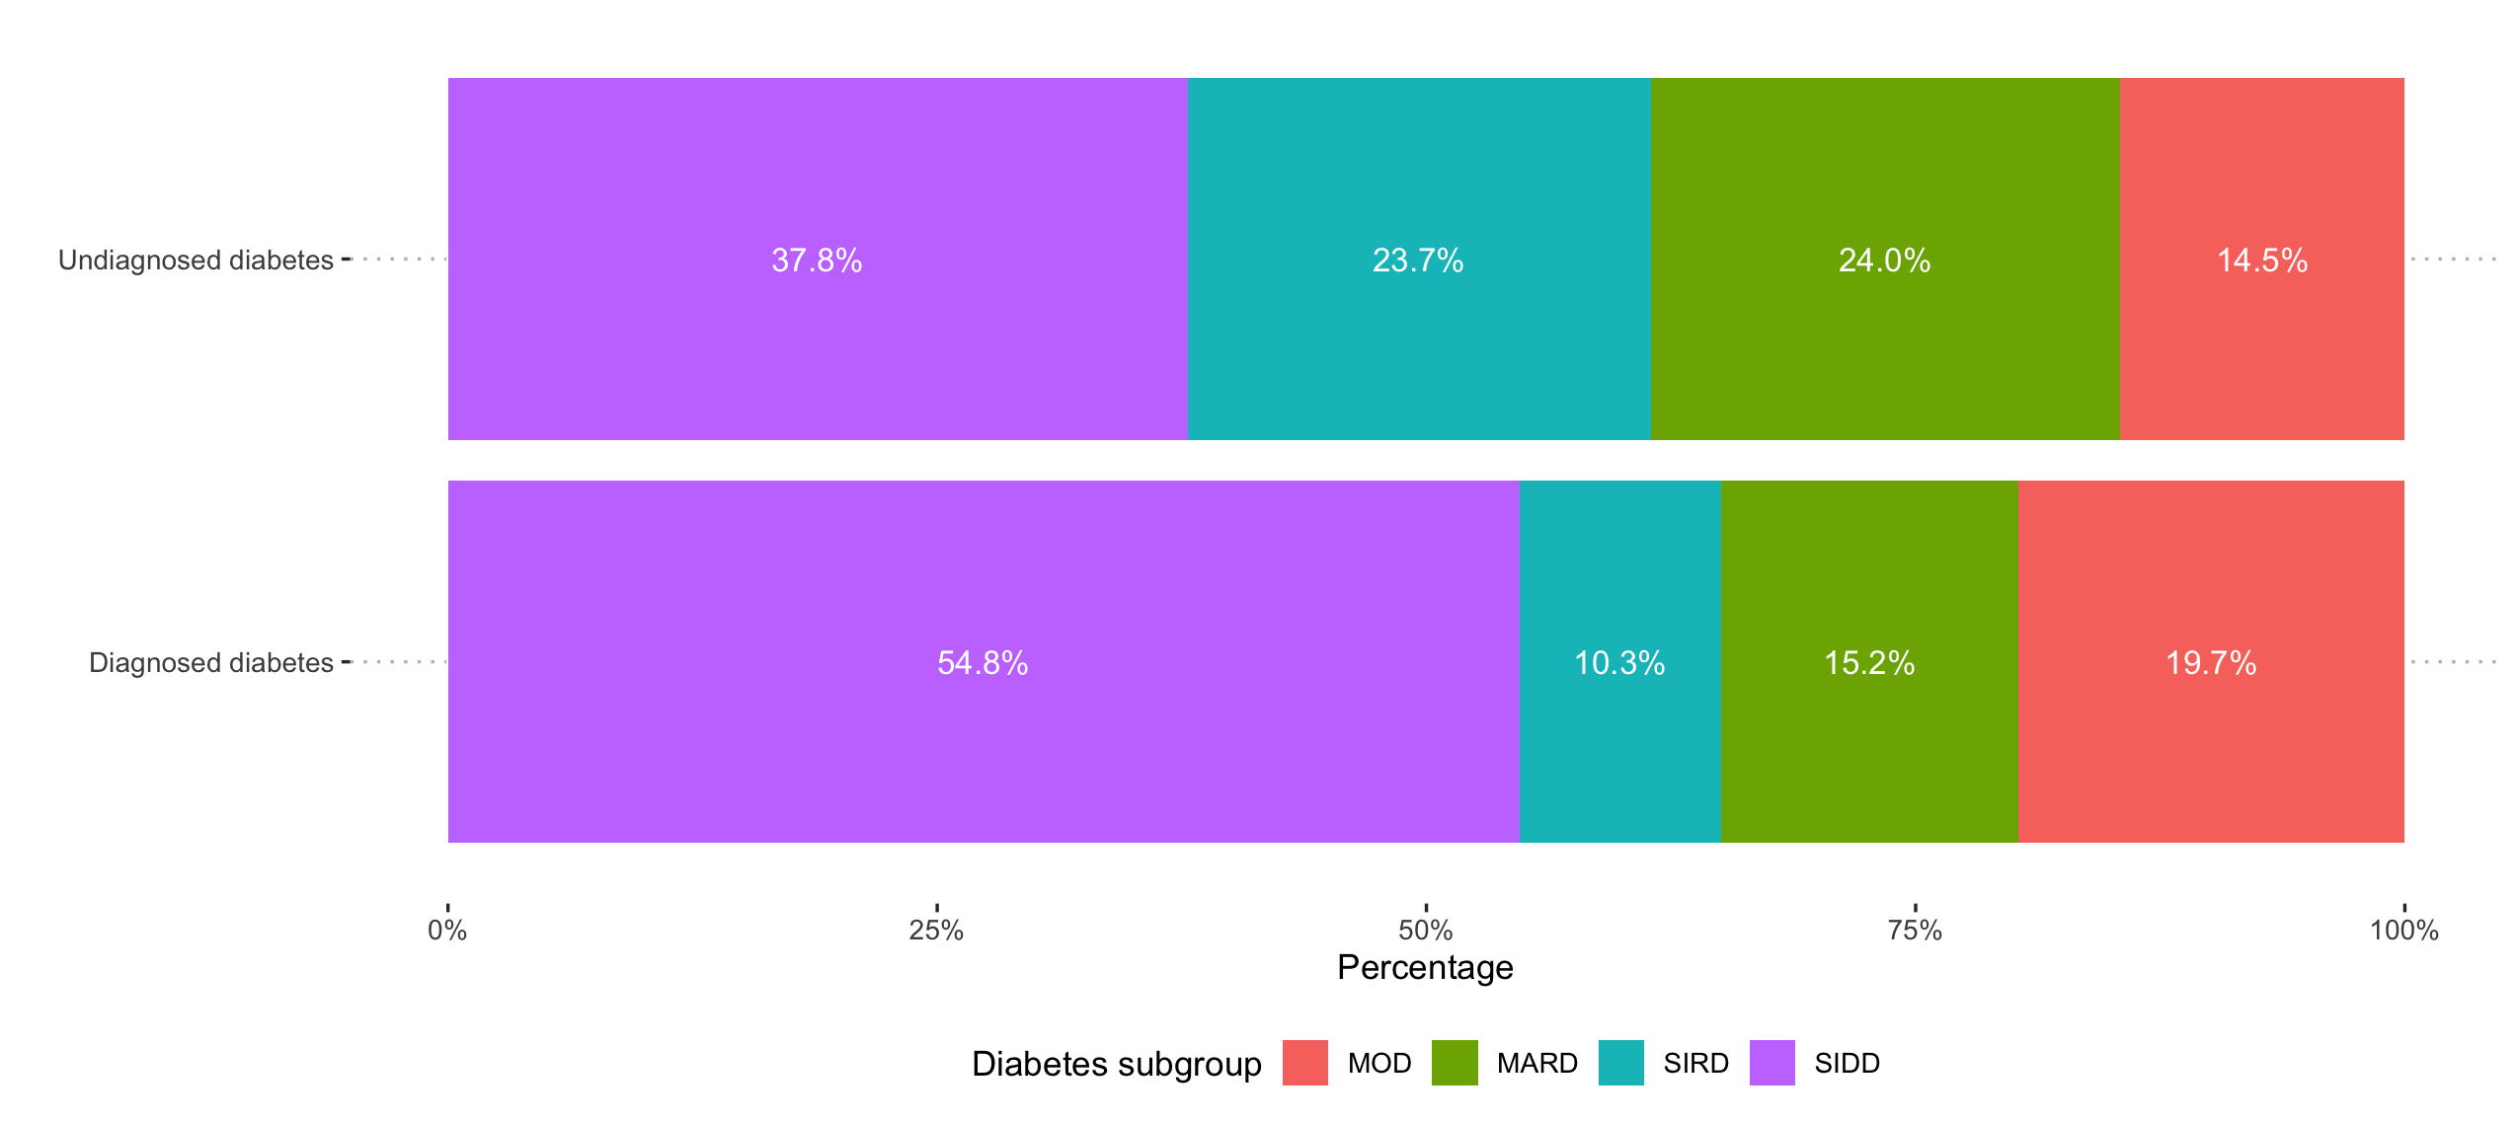
Supplementary Figure 1. Distribution of data-driven diabetes subgroups stratified by individuals with diagnosed (n=17,902) and undiagnosed diabetes (n=7,041) from the Mexico City Prospective Study without cardiovascular disease at baseline.

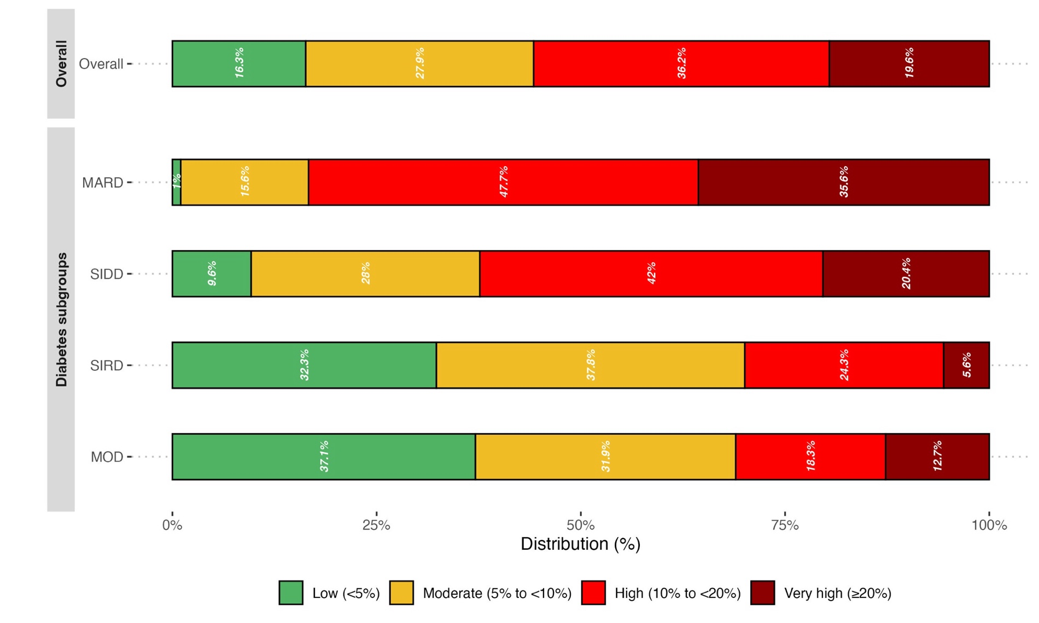
Supplementary Figure 2. Distribution of the SCORE2-Diabetes risk categories overall and across diabetes subgroups in MCPS using the original version of SCORE2-Diabetes.
Abbreviations: MOD, Mild Obesity-related Diabetes; MARD, Mild Age-related Diabetes; SIDD, Severe Insulin-Deficient Diabetes; SIRD, Severe Insulin-Resistant Diabetes.

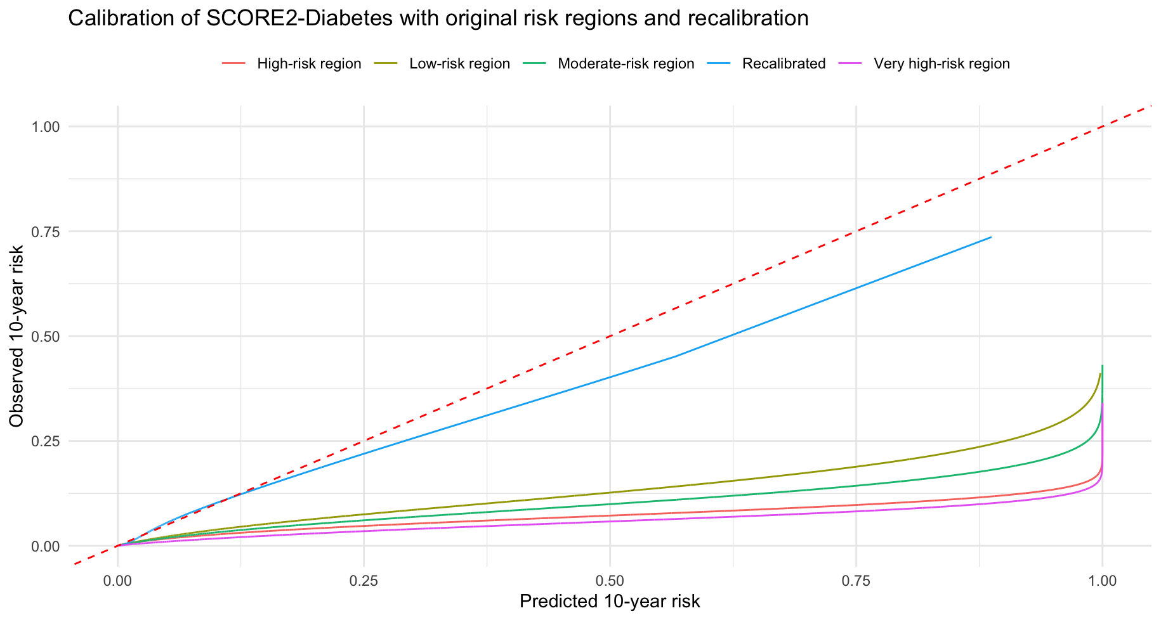

Supplementary Figure 3. Calibration of SCORE2-Diabetes for 10-year fatal cardiovascular disease events comparing the recalibration in the Mexico City Prospective Study with the region-specific recalibrations (low, moderate, high and very high risk) using the original SCORE2-Diabetes equations.

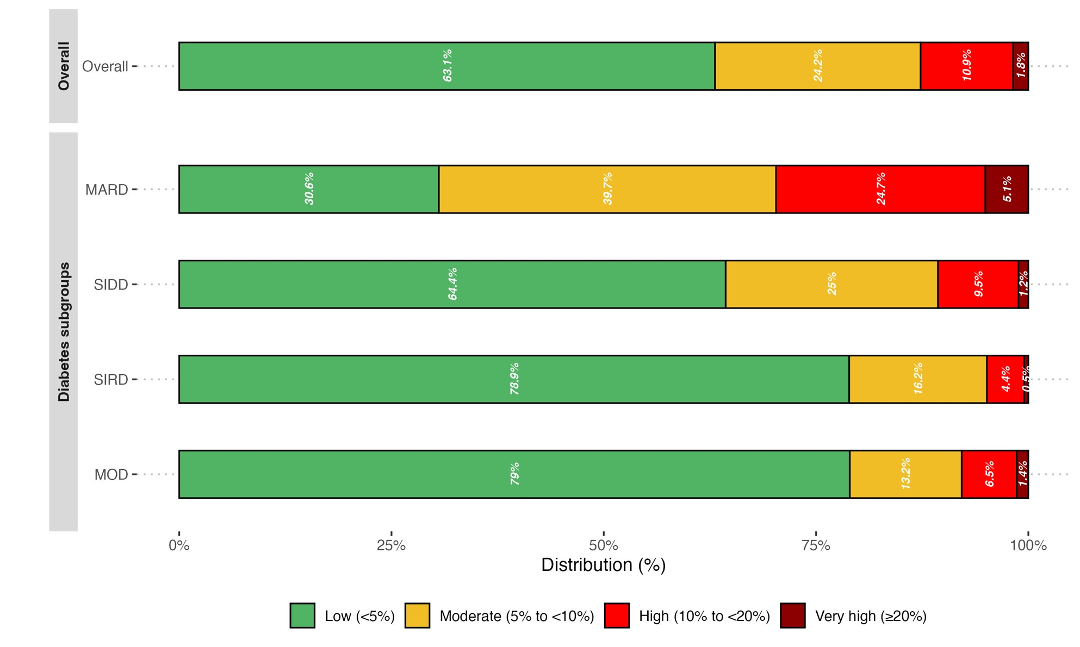
Supplementary Figure 4. Distribution of the SCORE2-Diabetes risk categories overall and across diabetes subgroups in MCPS using the recalibrated version of SCORE2-Diabetes for fatal CVD outcomes.
Abbreviations: MOD, Mild Obesity-related Diabetes; MARD, Mild Age-related Diabetes; SIDD, Severe Insulin-Deficient Diabetes; SIRD, Severe Insulin-Resistant Diabetes.

